WAFULA NELSON
CS/MK/1218/09/23
BMGT 214
BUSINESS PLAN

MAMBA CONSTRUCTION GROUP BUSINESS PLAN
1. EXECUTIVE SUMMARY
Introduction
Mamba construction group LLC plans to be a forerunner and a leading provider of concrete construction . To us this means always having the best and most efficient facilities , workforce and services offered to our clients. To reach this feat , MCG is investing in many ways that will pay off in competitive advantages for its customers.
The company’s overall strategy will be based on a continuing improvement process model of setting objectives ,measuring results and providing feedback to facilitate further growth and progress.
Mamba Construction Group is a limited liability company based in Nairobi. The management of the company is highly qualified and experienced . Mr John Maina leads the management with over 15 years of experience in the construction industry , having previously held senior managerial positions in other companies like The Tononoka Group an Doshi Limited.
Market
The construction industry in Kenya has experienced significant growth in recent years, driven by a combination of urbanization, infrastructure development, and increased demand for residential, commercial, and industrial properties. The government’s initiatives such as the Big Four Agenda, which focuses on affordable housing, manufacturing, universal healthcare, and food security, have provided a solid foundation for growth in the sector. Major infrastructure projects, including roads, bridges, airports, and railways, continue to propel the industry forward. Additionally, a rising middle class and increased foreign investment in Kenya have spurred further demand for both housing and commercial real estate developments.
The sector's growth has also been supported by the rise of construction technology and innovation, which are helping to improve efficiency, reduce costs, and enhance the quality of construction projects. Modern construction methods such as prefabrication, modular housing, and the integration of green building practices are gaining popularity in Kenya. The government’s push for affordable and sustainable housing projects has also led to a surge in demand for building materials and services that meet sustainability standards. These changes are not only improving the speed of construction but are also opening new opportunities for businesses to tap into the evolving trends within the industry.
MCG is planning to take advantage of the budding opportunities brought about by the earlier mentioned demand of skilled and high par construction services in the national push for faster rates of urbanization.
Financial considerations
We expect to be profitable during the first year of operations. Despite initial large outlays in cash in order to promote sales , the company’s cash account is expected to remain steady. We expect to be bringing in approximately Ksh 35 million by the end of the second financial year.

2. MISSION
The mission of our company is to deliver innovative, high-quality construction solutions that cater to the diverse needs of our clients, with a strong emphasis on sustainability, efficiency, and safety. We are dedicated to providing exceptional value through the integration of advanced technologies, skilled craftsmanship, and a customer-centric approach. By maintaining the highest standards in all aspects of our work, we strive to ensure that each project we undertake contributes positively to both the built environment and the communities we serve.
Our goal is to play a significant role in the growth and development of Kenya's infrastructure and real estate sectors, creating impactful projects that foster economic progress and improve the quality of life. Through a commitment to integrity, collaboration, and excellence, we aim to become a leading force in the construction industry. By consistently exceeding client expectations, we seek to build long-lasting relationships and leave a lasting legacy of well-executed, sustainable developments that stand the test of time.

3. COMPANY SUMMARY
Startup Expenses
Legal………………………………………….$1,000
Stationery……………………………………..$2,000
Brochures……………………………………..$8,000
Consultants……………………………………$4,500
Insurance………………………………………$19,000
Office space rent………………………………$5,000
Expensed equipment…………………………..$4,000
Other……………………………………………$2,000
Total startup expenses $45,500

Startup assets
Cash required……………………………………$10,000
Startup inventory………………………………...$0
Other current assets……………………………...$2,000
Long term assets………………………………...$4,000
Total assets……………………………………...$19,000
Total funding required $35,000

Liabilities and capital
Current borrowing……………………………….ksh0
Long term liabilities……………………………..ksh0
Outstanding bills………………………………….ksh0
Other current liabilities……………………………ksh0
Total liabilities ksh0

4. SERVICES
The MCG system can be adapted to almost any construction requirement that calls for forming. The company’s expert staff has the capability to design and manufacture any custom component or accessory item that may be required to complete the formwork package.
Owners, developers, construction managers, general contractors, and concrete subcontractors have realized substantial savings in labor and material costs by using structural contours construction methods, systems and equipment. Applications include commercial and residential structures, bridges, educational projects, recreational projects, civil projects, tunnels, utility projects, environmental projects, and virtually every other type of concrete construction.
Mamba Construction’s formworks will offer major advances, complete adaptability, and high strength-to-weight ratio, and all at cost effective prices. Assembly will be quick and easy. During form use, maintenance will be minimal. Concrete Installation will recommend, as a safety precaution, occasional inspection for bolts and nuts that may have loosened from handling.
The required formwork drawings that MCG will furnish to the contractor eliminate all guesswork. The company will specify the order of assembly and erection including the location of the strongbacks and joists, the location and actual loading of the form ties, location of all accessories and advise clients of the maximum allowable rate of concrete placement.
Accident prevention is the cornerstone of MCG’s safety commitment. The company will strive to eliminate foreseeable hazards which could result in personal injury or illness; at Mamba Construction Group, health and safety will not be compromised. MCG will sell its services clients in the area of commercial construction.
Applications
The following applications are uses for MCG’s services.
- Foundations
- Parking Lots
- Parking Garages
- Low Rise/Tilt-Up
- High Rise
- Flowable Fill/Soil Displacement
- Retaining Walls

5. MARKET ANALYSIS
Industry Statistics – Concrete Work
Special trade contractors primarily engaged in concrete work, including Simba cement and asphalt.
Estimated number of Kenyan establishments | 30,214
Number of people employed in this industry | 230,338
Total annual sales in this industry | $1.3 billion
Average employees per establishment | 250
Average sales per establishment | $34 million
Establishments primarily engaged in manufacturing Simba cement concrete manufactured and delivered to a purchaser in a plastic and unhardened steel.
Estimated number of Kenyan establishments | 5,798
Number of people employed in this industry | 89,662
Total annual sales in this industry | $9 million
Average number of employees per establishment | 17
Average sales per establishment | $25,000

Market segmentation
The housing industry has proceeded at a red-hot pace for several years running. An all-time record was set in 1998, when 886,000 new-site single family homes were sold. That represented a 10% gain from the robust total of 804,000 homes sold in 1997, and an 8.1% rise from the prior record of 819,000 units in 1977. Single-family housing construction accounted for ksh4.8 billion of the total ksh23 billion generated in the industry.
Home sales strengthened even further during most of 1999’s first 10 months. In that period, new single-family home sales increased by 4.8% on a year-to-year basis, to 791,000 units, according to the Government of Kenya Ministry of Housing. Through October 1999, seasonally adjusted sales had exceeded 800,000 on an annualized basis in every month since the start of 1998.
The record setting string of home sales since the second half of 1997 has forced builders to pick up the pace of their construction activity. During 1998, total starts increased by 9.7% to 1.62 million units. Starts for single family units moved up 12 % for the year, and those of multifamily units were ahead by 1.5%. As an indication of building activity at year-end 1999, housing starts in November 1999 came in at a seasonally-adjusted annual rate of 1.6 million units.
The table below outlines the total market potential of the three targeted market segments in the served markets (in $ thousands).

Potential Customers | Growth |  |  |  |  |  | CAGR
Single-family housing construction | 8% | 125,000 | 135,000 | 145,800 | 157,464 | 170,061 | 8.00%
Residential construction | 5% | 25,000 | 26,250 | 27,563 | 28,941 | 30,388 | 5.00%
Heavy construction | 5% | 50,000 | 52,500 | 55,125 | 57,881 | 60,775 | 5.00%
Total | 6.90% | 200,000 | 213,750 | 228,488 | 244,286 | 261,224 | 6.90%
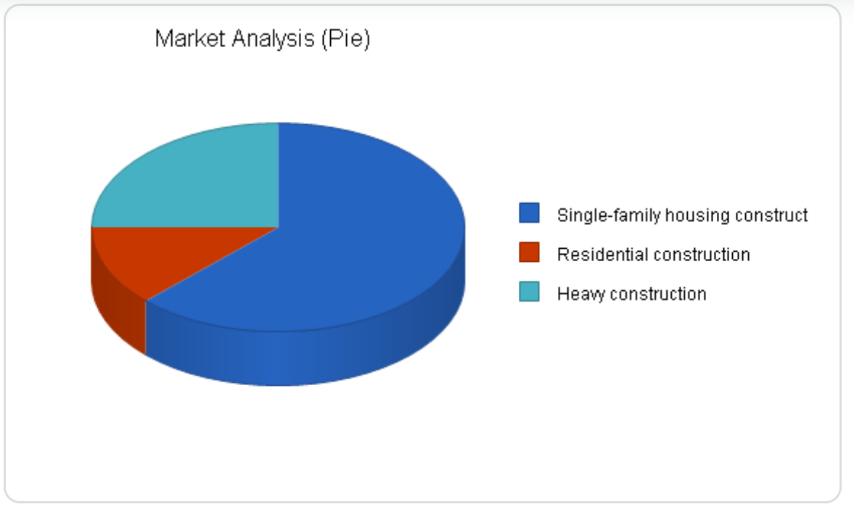

5. STRATEGY IMPLEMENTATION SUMMARY
MCG will focus on a dual strategy of differentiation and cost efficiency to establish a competitive edge in the market. The differentiation will be achieved through a commitment to sustainable construction practices, innovative design solutions, and the use of advanced construction technologies such as Building Information Modeling (BIM) and modular construction. By positioning itself as a leader in eco-friendly and technologically advanced building solutions, the company will attract environmentally conscious clients and those seeking cutting-edge construction methods. Simultaneously, cost efficiency will be maintained through strategic partnerships with suppliers, lean construction practices, and optimized project management to deliver high-quality projects within budget and on time.
The implementation of the strategy will begin with the establishment of a skilled and versatile workforce, including architects, engineers, project managers, and construction workers trained in sustainable practices and modern technologies. The company will invest in state of the art construction software and equipment to streamline operations and enhance productivity. A phased approach will be adopted for market entry, starting with smaller residential and commercial projects to build a portfolio and reputation, followed by expansion into larger, more complex projects. Key performance indicators (KPIs) such as project completion time, cost variance, client satisfaction, and sustainability metrics will be monitored to ensure alignment with strategic goals.
To secure a strong market position, the company will leverage targeted marketing campaigns highlighting its unique value proposition, including sustainability certifications, energy-efficient designs, and successful project case studies. Strategic alliances with real estate developers, government agencies, and environmental organizations will be prioritized to secure contracts and enhance credibility. Over time, the company plans to expand its geographic reach and diversify its service offerings to include renovation, infrastructure development, and smart building solutions. By consistently delivering quality, innovative, and sustainable construction projects, the company aims to build long-term client relationships and achieve steady growth in a competitive industry.

Sales forecast
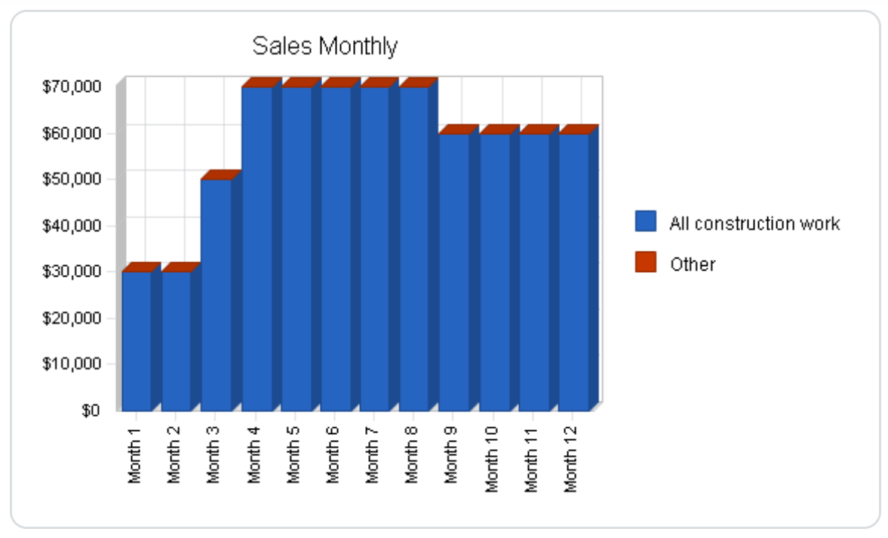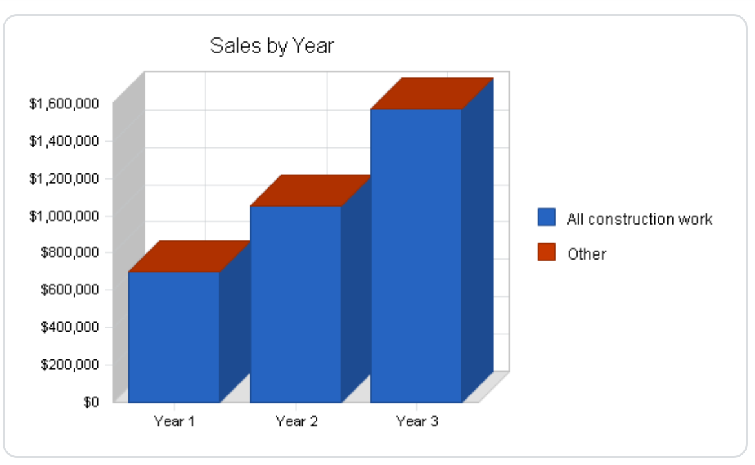

Sales Forecast
Sales
All construction work | Ksh7,000,000 | $1,050,000 | $1,575,000
Other | $0 | $0 | $0
Total Sales | $700,000 | $1,050,000 | $1,575,000
Direct Cost of Sales | Year 1 | Year 2 | Year 3
All construction work | $448,000 | $558,750 | $698,437
Other | $0 | $0 | $0
Subtotal Direct Cost of Sales | $448,000 | $558,750 | $698,437

Marketing strategy
MCG plans to use a direct sales force, relationship selling, and subcontractors to reach its markets. These channels are most appropriate because of time to market, reduced capital requirements, and fast access to established distribution channels. The overall marketing plan for MCG’s service is based on the following fundamentals:
- The segment of the market(s) planned to reach.
- Distribution channels planned to be used to reach market segments: television, radio, sales associates, and mail order.
- Share of the market expected to capture over a fixed period of time.
In addition, MCG plans to advertise in magazines, newspapers, and radio.
The table and chart below outline the company’s sales forecast for FY2025-2026. In our sales forecasts, the cost of sales includes only direct labor costs (administrative labor costs are discussed below).
Promotional Campaign
MCG is committed to an extensive promotional campaign. This will be done aggressively and on a broad scale. To accomplish initial sales goals, the company will require an effective promotional campaign to accomplish two primary objectives:
- Attract customers who will constantly look to our company for their construction projects.
- Attract quality sales personnel who have a desire to be successful.
In addition to standard advertisement practices, Mamba Construction will gain considerable recognition through these additional promotional mediums:
- Press releases sent to major radio stations, newspapers, and magazines.
- Radio advertising on secondary stations.
Marketing Programs
For the first six months of operation, advertising and promotion is budgeted at approximately $11,000. A fixed amount of sales revenues will go toward the state Concrete Installation advertisement campaign. On an ongoing basis, our organisation feels that it can budget advertising expenses at less than 10% of revenues.
Incentives. As an extra incentive for customers to remember MCG’s name, the company plans to distribute coffee mugs, T-shirts, pens, and other advertising specialties with its logo.
Brochures. The objective of brochures is to portray MCG’s goals and products as an attractive functionality. It is also to show customers how to use the latest in technology as it relates to construction and building services. MCG will develop three brochures: one to be used to promote sales, one to use to announce the product in a new market, and the other to recruit sales associates.

6. FINANCIAL PLAN
The following sections describe the financials for Mamba Consruction
Projected Cash Flow
Projected cash flow statements for FY2025-2026 are provided below.
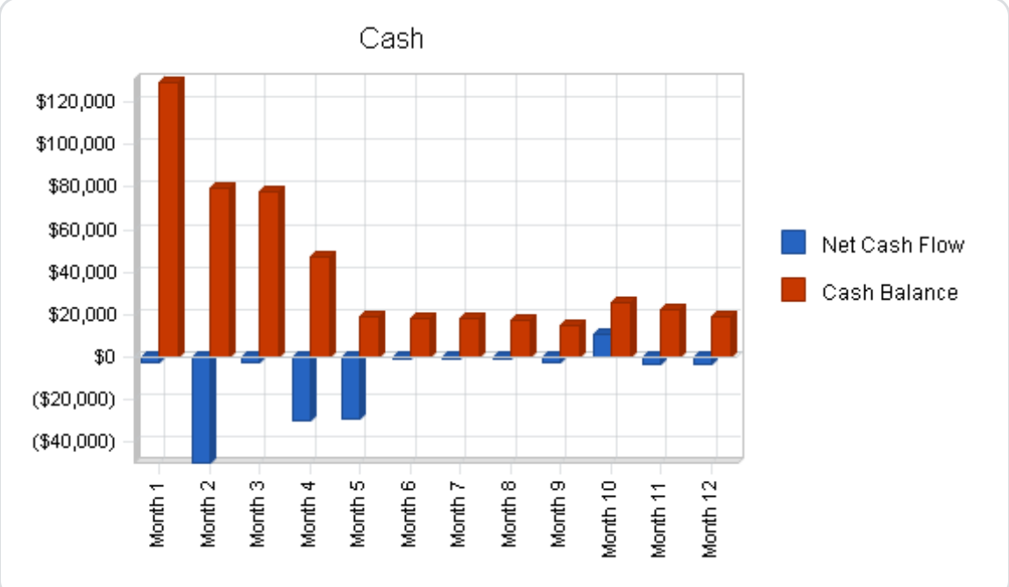

Pro Forma Cash Flow
Cash Received
Cash from Operations
Cash Sales | $175,000 | $262,500 | $393,750
Cash from Receivables | $436,500 | $743,250 | $1,114,875
Subtotal Cash from Operations | $611,500 | $1,005,750 | $1,508,625
Additional Cash Received
Sales Tax, VAT, HST/GST Received | $0 | $0 | $0
New Current Borrowing | $0 | $0 | $0
New Other Liabilities (interest-free) | $0 | $0 | $0
New Long-term Liabilities | $0 | $0 | $0
Sales of Other Current Assets | $0 | $0 | $0
Sales of Long-term Assets | $0 | $0 | $0
New Investment Received | $0 | $0 | $0
Subtotal Cash Received | $611,500 | $1,005,750 | $1,508,625

Break even analysis

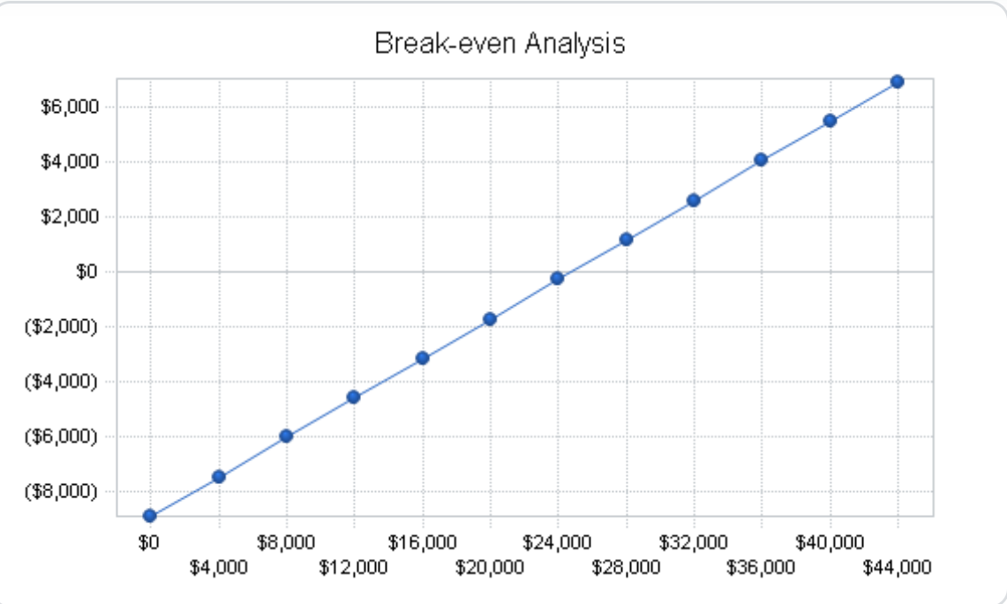
Break-even Analysis
Monthly Revenue Break-even | $24,706
Assumptions:
Average Percent Variable Cost | 64%
Estimated Monthly Fixed Cost | $8,894

Projected Profit and Loss

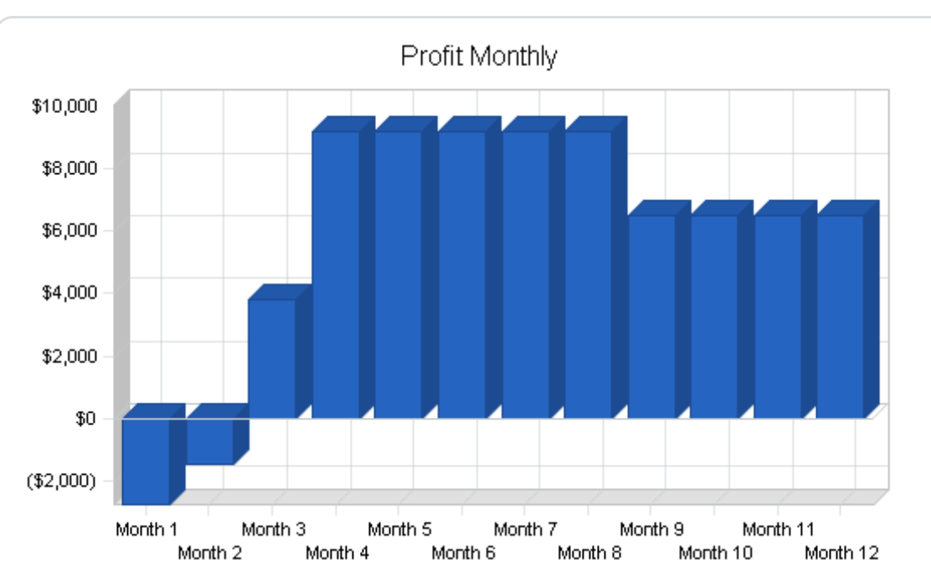
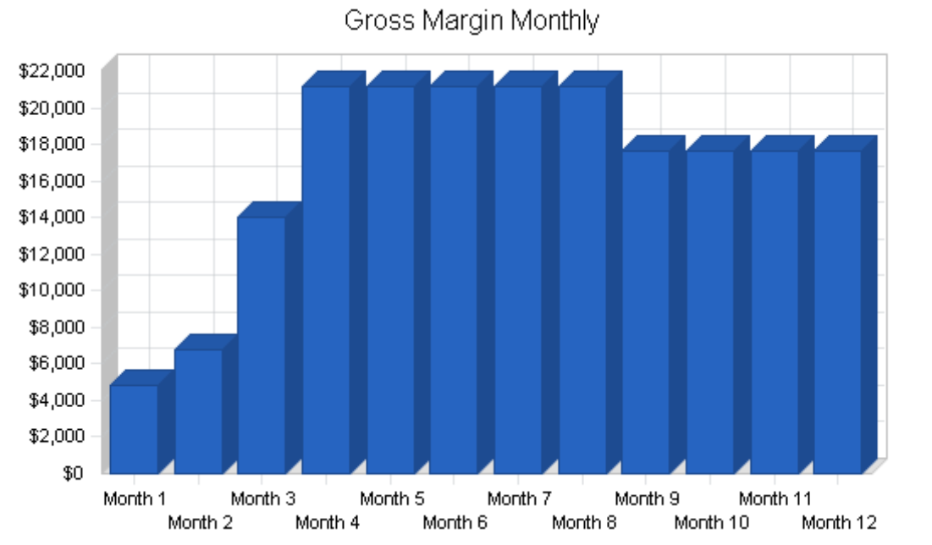

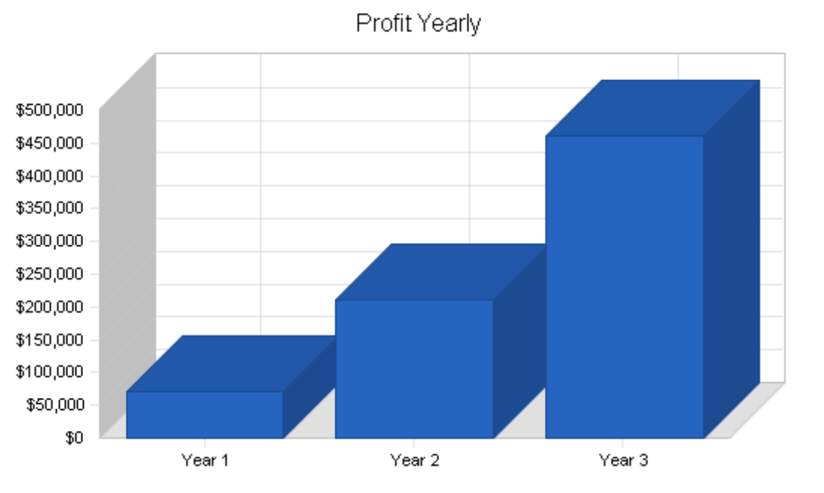
Projected Balance Sheet
Pro Forma Balance Sheet
Assets
Current Assets
Cash | $19,418 | $98,662 | $408,533
Accounts Receivable | $88,500 | $132,750 | $199,125
Inventory | $42,240 | $52,682 | $65,853
Other Current Assets | $30,000 | $30,000 | $30,000
Total Current Assets | $180,158 | $314,094 | $703,510
Long-term Assets
Long-term Assets | $125,000 | $225,000 | $325,000
Accumulated Depreciation | $3,600 | $8,600 | $14,600
Total Long-term Assets | $121,400 | $216,400 | $310,400
Total Assets | $301,558 | $530,494 | $1,013,910

Liabilities and Capital | Year 1 | Year 2 | Year 3
Current Liabilities
Accounts Payable | $47,908 | $65,832 | $87,828
Current Borrowing | $0 | $0 | $0
Other Current Liabilities | $0 | $0 | $0
Subtotal Current Liabilities | $47,908 | $65,832 | $87,828
Long-term Liabilities | $0 | $0 | $0
Total Liabilities | $47,908 | $65,832 | $87,828
Paid-in Capital | $215,000 | $215,000 | $215,000
Retained Earnings | ($33,000) | $38,650 | $249,663
Earnings | $71,650 | $211,013 | $461,419
Total Capital | $253,650 | $464,663 | $926,082
Total Liabilities and Capital | $301,558 | $530,494 | $1,013,910
Net Worth | $253,650 | $464,663 | $926,082

Business Ratios
Ratio Analysis
Sales Growth | 0.00% | 50.00% | 50.00% | 7.50%

Percent of Total Assets
Accounts Receivable | 29.35% | 25.02% | 19.64% | 30.90%
Inventory | 14.01% | 9.93% | 6.49% | 6.30%
Other Current Assets | 9.95% | 5.66% | 2.96% | 29.80%
Total Current Assets | 59.74% | 59.21% | 69.39% | 67.00%
Long-term Assets | 40.26% | 40.79% | 30.61% | 33.00%
Total Assets | 100.00% | 100.00% | 100.00% | 100.00%
Current Liabilities | 15.89% | 12.41% | 8.66% | 43.50%
Long-term Liabilities | 0.00% | 0.00% | 0.00% | 14.10%
Total Liabilities | 15.89% | 12.41% | 8.66% | 57.60%
Net Worth | 84.11% | 87.59% | 91.34% | 42.40%
Activity Ratios
Accounts Receivable Turnover | 5.93 | 5.93 | 5.93 | n.a
Collection Days | 57 | 51 | 51 | n.a
Inventory Turnover | 10.91 | 11.77 | 11.78 | n.a
Accounts Payable Turnover | 13.01 | 12.17 | 12.17 | n.a
Payment Days | 27 | 26 | 26 | n.a
Total Asset Turnover | 2.32 | 1.98 | 1.55 | n.a
Debt Ratios
Debt to Net Worth | 0.19 | 0.14 | 0.09 | n.a
Current Liab. to Liab. | 1.00 | 1.00 | 1.00 | n.a
Liquidity Ratios
Net Working Capital | $132,250 | $248,263 | $615,682 | n.a
Interest Coverage | 0.00 | 0.00 | 0.00 | n.a
Additional Ratios
Assets to Sales | 0.43 | 0.51 | 0.64 | n.a
Current Debt/Total Assets | 16% | 12% | 9% | n.a
Acid Test | 1.03 | 1.95 | 4.99 | n.a
Sales/Net Worth | 2.76 | 2.26 | 1.70 | n.a
Dividend Payout | 0.00 | 0.00 | 0.00 | n.a

6. APPENDIX
Attached to this plan are:
  - The resumes of our founder along with those of our key team members and other management staff
  - Business licenses and permits
  - Prototypes and blueprints for some of our products
  - Patents and trademarks

